Can Blockchain Save our Healthcare System?- Puneet Gupta

“Did the Bitcoin Bubble Just Burst?”1 This latest news headline and many others immediately and frequently catch our attention with key terms such as Bitcoin, cryptocurrency, and blockchain. We’ve all heard of the cryptocurrency or digital asset Bitcoin, but few understand it. More importantly, even fewer understand the technology that underlies it: blockchain. Although Bitcoin and other cryptocurrencies have a great potential to reshape our global economy and financial industry, the underlying blockchain technology has the potential to transform every industry in our world today, especially healthcare, which is currently in a state of disarray. As J.P. Morgan Chase CEO Jamie Dimon recently said, “Blockchain is real.”2 But what is this blockchain technology and can it save our healthcare system?

What is blockchain technology?

A blockchain is simply a digital ledger, or essentially a digital book, that can maintain a series of records of data for all parties involved in the network3. Blockchains have been critically designed to be secure, decentralized, and transparent. The security arises from how different blocks, each of which contains certain data, such as from a transaction or contract, are timestamped and cryptographically linked, thereby forming a chain of blocks3. Each block contains two cryptographic hashes, or simply digital fingerprints: one is generated using the data in that block and the second is simply the hash of the previous block4. If the data in a block is changed, then its hash will change and no longer match the hash value originally stored in the block ahead of it. Thus, any attempt to change the information in one of the blocks of the chain can be spotted, thereby preventing any data removal or tampering3. These cryptographic hashes form the crux of the immutability of blockchains, though there are often other features of the chain that play a role as well, such as the proof-of-work mechanism.

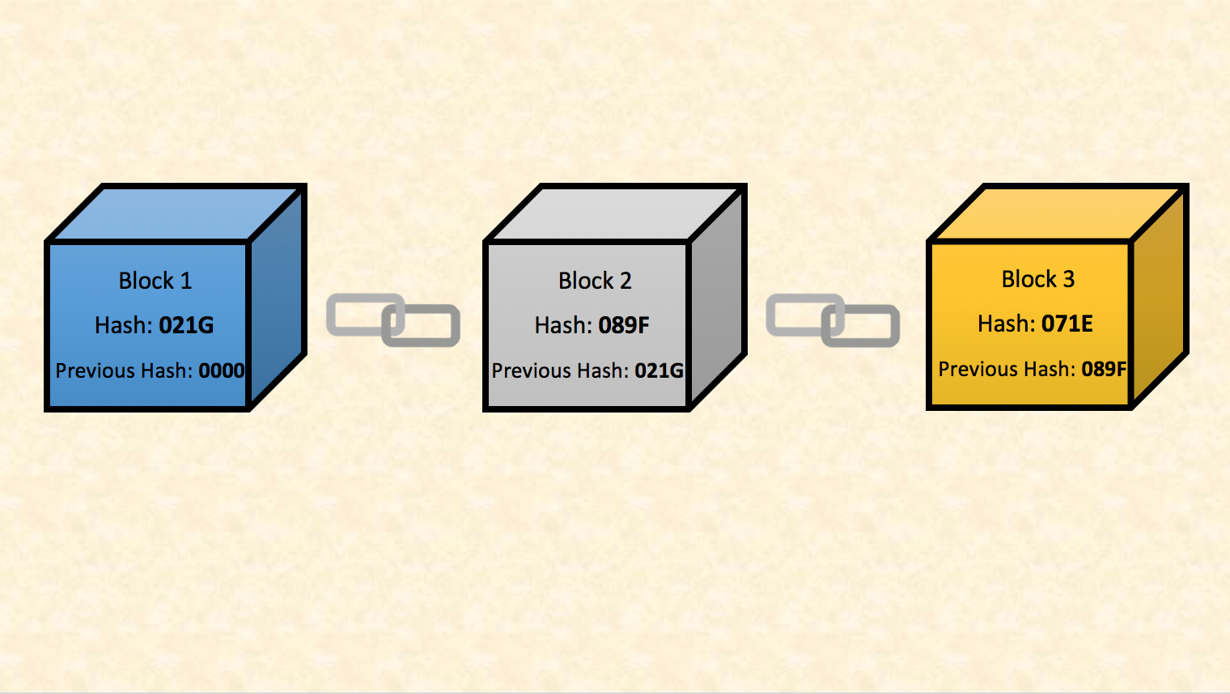

Figure 1: A sample blockchain model showing how different blocks are linked through cryptographic hashes.

The decentralized nature of blockchains arises from how each party in the network has a copy of the most up-to-date blockchain and how a block can only be added to the blockchain if verified by a majority of parties within the network5. Once a block is validated, each party has their copy updated to ensure all records match. This distributed design of blockchains also makes it nearly impossible for blockchains to be compromised or hacked. In contrast, most of our current systems, such as banking, are far more centralized. In these systems, a central organization, such as the Federal Reserve, or person has dominant control over the verification and regulation of these databases. In blockchains, since transactions can occur directly between the parties involved in the network with approval from majority of the parties, the need for middlemen, such as the government, is often eliminated6.

The transparency of blockchains arises from how the different blocks of information can be traced and viewed by the different parties of the network. Moreover, each party knows that each block has been validated and not unknowingly been modified3,4. Either all or certain data in these blocks can be viewed by all parties in the network depending on how the blockchain is designed or modeled. These variations in a blockchain’s design allows for its application to different fields and purposes. The complexity of novel blockchain models or designs is currently being explored and researched for specific applications, as different blockchains can have different features that are specific for their purpose. Overall, the security, decentralization, and transparency in the design of blockchains gives people hope that its implementation into different industries will bring greater trust, security, and reduced costs within those industries.

Blockchain in the Financial Ecosystem

With the elimination of intermediaries, transparency, and security being some of the greatest advantages of blockchain technology, there’s no surprise that a majority of the earliest adopters, researchers, and innovators of this technology were interested in applying it to our banking and financial systems7. Financial institutions and fintech startups are partnering together and are actively interested in applying blockchain for wholesale payments, clearing and settlements, issuing debt and equity, management, and more7. Many new cryptocurrencies have been developed in hopes of becoming the most efficient, effective, and widely adopted, whether it be for general money transfers, for specific financial institutions like investment banks, or even for non-monetary use8. Some of these Bitcoin alternatives, also referred to as “altcoins,” have been growing rapidly, including Ripple, Litecoin, Monero, and Ether8. Nonetheless, blockchain technology has begun to disrupt the financial ecosystem, as many large firms including Accenture, McKinsey & Company, IBM, and Deloitte are investigating this ripe technology9.

Blockchain in Healthcare

The advent of blockchain technology and its promising future have spurred unparalleled investments and interest in applying it to healthcare. Blockchain’s ability to disrupt the current healthcare ecosystem and infrastructure has triggered a rise in many startups and businesses entering this unfolding industry.

Within healthcare, blockchain can have a large impact in many aspects. Heavy attention has been specifically focused on electronic health records and patient data. Currently, one of the biggest issues with patient data involves the interoperability of different systems or softwares within and between organizations, and even the privacy and security associated with those data when communicated between systems. The consequences of healthcare data interoperability are vast. In an era of technological advancements, repeatedly filling out bundles of paper forms at different hospitals and clinics is shameful. Redundant testing is not only a greater financial burden on the system and patient, but also simply ineffective and a waste of time. Poor coordination and miscommunication among multiple providers working on a patient increases chances of erroneous diagnoses and ineffective therapies.

There is a great potential for blockchain to streamline and function as a distributed database for improving interoperability. In the future, we hope that from a single blockchain, patient data can be readily accessed by all providers, researchers, and patients themselves. The beauty of blockchain technology is its ability to make this secured patient data easily accessible while simultaneously maintaining patient privacy through its cryptographic public and private keys. Moreover, through this blockchain technology, patients can access their life-long health history privately while also being able to share certain aspects of their data with healthcare providers and organizations. Giving patients more access and control of their own data is critical for healthcare’s primary goal of delivering patient-centered care. Patients will become more involved in their own care and will be better able to make informed decisions about their treatment or therapy options.

Integrating patient data on blockchain technology will have an unfathomable impact on the pace of new discoveries in biomedical research, both in laboratories and clinics. Rapid access to patient data through the blockchain would allow researchers to investigate large amounts of data simultaneously. With these large data sets, researchers can better investigate various topics at the population level, including health trends over time, differences in disease susceptibility among ethnic groups, differences in a drug’s effectiveness between sexes, and much more. These large patient data sets are also critical for building and training machine learning algorithms that can predict these trends and increased disease susceptibilities. Most importantly, principal investigators and research organizations could rapidly access this patient data without having the patient’s identity compromised.

Even outside the clinic and research institutions, blockchain in the healthcare infrastructure has been proposed for many smaller, yet critical, areas. For example, blockchain technology may be used for monitoring and maintaining active records of all healthcare providers, including their certifications, hospital affiliations, education, and more. Healthcare providers are frequently changing where they practice, their specialties, and recertifying; thus, a blockchain-based system will allow for regulation, monitoring, and even fraud prevention10. Blockchains also have the potential to resolve many of the issues we face today in medication adherence and drug abuse, areas of high concern due to the current opioid overdose epidemic. Through blockchain technology, the manufacturing and prescribing of these drugs can better be traced and monitored, preventing drug misuse and repetitive prescriptions11. Blockchain’s function as an immutable digital ledger has even pushed innovators to explore its use in managing the issue of counterfeit pills in the pharmaceutical supply chain and even for managing clinical trials for novel therapeutics.

In order to show the interest of companies in blockchain for healthcare, a recent Deloitte survey found that 35 percent of blockchain-knowledgeable healthcare senior executives in healthcare were planning to implement blockchain12. Many new startups are also aiming to apply blockchain to various aspects of the healthcare system. Some companies currently pursuing blockchain in healthcare include PokitDok, Gem, and Guardtime. PokitDok is looking at interoperability, Gem is investigating reimbursement models, and Guardtime is exploring health data security13.

The ability for blockchain technology to make large amounts of data immutable, secure, private, and accessible inspires many to work towards its large-scale adoption in healthcare, especially for interoperability. This interoperability will drive a rapid increase in the rate of medical research discoveries and innovations by allowing researchers to access large sets of patient data while maintaining patient privacy. The distributed ledger design and elimination of middlemen have driven people to believe that this technology can bring back trust in the systems to which it is adopted in14. Moreover, in healthcare specifically, this future elimination of middlemen may drive down healthcare costs and reduce fraudulent activity in medical billing and insurance. Because this is such a new and emerging technology, current healthcare guidelines and regulations for the implementation and integration of blockchain technology are not yet established. These regulatory standards could be a potential barrier to the widespread adoption of blockchain. There is hope that in the coming years a better understanding of this technology will promote its integration and eventual disruption of the industry. Overall, the possibilities are endless for applying this revolutionary blockchain technology to medicine in order to transform and save the healthcare ecosystem.

Works cited

[1] Barlow, S. Did the bitcoin bubble just burst? The Globe and Mail, Jan. 17, 2018. <https://www.theglobeandmail.com/globe-investor/inside-the-market/did-the-bitcoin-bubble-just-burst/article37632595/>

[2] Cao, S. JP Morgan CEO Jamie Dimon: Blockchain Is Real, Not Interested in Bitcoin. Observer, Jan. 9, 2018. <http://observer.com/2018/01/jp-morgan-jamie-dimon-blockchain-real-not-interested-bitcoin/> (accessed Feb. 17, 2018).

[3] Blockchain: The New Technology of Trust. Goldman Sachs. <http://www.goldmansachs.com/our-thinking/pages/blockchain/> (accessed Feb. 14, 2018).

[4] Norton, S. CIO Explainer: What Is Blockchain? The Wall Street Journal, Feb. 2, 2016. <https://blogs.wsj.com/cio/2016/02/02/cio-explainer-what-is-blockchain/> (accessed Feb. 14, 2018).

[5] Watters, A. The Blockchain for Education: An Introduction. April 7, 2016. <http://hackeducation.com/2016/04/07/blockchain-education-guide> (accessed Feb. 14, 2018).

[6] Tapscott, D. How blockchains could change the world. May 2016. McKinsey & Company. <https://www.mckinsey.com/industries/high-tech/our-insights/how-blockchains-could-change-the-world> (accessed Feb. 15, 2018).

[7] Blockchain rewires financial markets. IBM, 2017. <https://www-01.ibm.com/common/ssi/cgi-bin/ssialias?htmlfid=GBP03469USEN&>.

[8] What is an Altcoin? <https://bitcoinmagazine.com/guides/what-altcoin/> (accessed Feb. 16, 2018).

[9] Market Guide for Blockchain Consulting and Proof-of-Concept Development Services. Gartner, Feb. 22, 2017. https://de.nttdata.com/fileadmin/web_data/country/de/News/  
market_guide_for_blockchain__317612.pdf

[10] Bresnick, J. Five Blockchain Use Cases for Healthcare Payers, Providers. <https://healthitanalytics.com/news/five-blockchain-use-cases-for-healthcare-payers-providers> (accessed Feb. 16, 2018).

[11] Blockchain Technology Holds the Answer for the Prescription Drug Crisis. NewsBTC, Jan. 7, 2018. https://www.newsbtc.com/2018/01/07/blockchain-technology-holds-answer-prescription-drug-crisis/ (accessed Feb. 16, 2018).

[12] Deloitte survey: Blockchain reaches beyond financial services with some industries moving faster. Deloitte, Dec. 13, 2016. [https://www2.deloitte.com/us/en/pages/about-deloitte/  
articles/press-releases/deloitte-survey-blockchain-reaches-beyond-financial-services-with-some-industries-moving-faster.html](https://www2.deloitte.com/us/en/pages/about-deloitte/articles/press-releases/deloitte-survey-blockchain-reaches-beyond-financial-services-with-some-industries-moving-faster.html) (accessed Feb. 15, 2018).

[13] CB Insights. Sept. 21, 2017. <https://www.cbinsights.com/research/healthcare-blockchain-startups-medicine/> (accessed Feb. 16, 2018).

[14] Blockchain: A new mechanism for trust—no intermediary required. Deloitte. https://qz.com/628581/blockchain-a-new-mechanism-for-trust-no-intermediary-required/ (accessed Feb. 18, 2018).